Czech University of Life Sciences Prague

Faculty of Economics and Management

Department of Information Technologies



Project Documentation   
Web Design

LIVE NEWS

Fatih Kenan Şenyurt

Omer Aysan

Seyit Berk Yavuz

© 2024

Contents

**Introduction** 3

**1. About Us** 3

**2. Our Mission** 3

**3. Why Choose Live News?** 3

**Key Features** 4

**4. Objectives** 4

Implementation Requirements 5

1. How the Website Should Behave 9

2. Proposed Technologies 10

2. Tools Used 10

Use of AI tools 11

3. Scenario: Leveraging ChatGPT During the Project 11

1. Subchapter Level 2 12

1. Subchapter level 3 13

2. Subchapter Level 2 13

Fulfilment Of Project Requirements 14

1.Navigation Bar 14

2.Search Bar and Category Navigation 16

4- Hot Topic Banner News 20

5 Popular News and Latest News 22

6 About Us, Stay Updated and Contact Us 24

7 - Categories (Latest in Technology, Health, Science, Business and Entertainment) 26

8- Author Page 28

9-Subscription Page 29

**Introduction**

**Live News** is a state-of-the-art news platform designed to deliver comprehensive and real-time updates on events across various domains such as technology, health, business, science, and entertainment. The platform is built to serve a global audience with diverse interests, ranging from professionals and industry experts to casual readers. By offering credible, engaging, and easily accessible content, **Live News** aims to become a trusted source of information in an increasingly fast-paced and interconnected world. Whether you are looking for the latest breakthroughs in science or insights into global business trends, Live News has you covered.

**1. About Us**

At **Live News**, we pride ourselves on being a team of passionate journalists, editors, and content creators who share a common goal: to inform and inspire. Our diverse team works tirelessly to curate, verify, and present news stories that matter to our readers. We believe in the power of accurate and well-researched journalism to foster informed decision-making and meaningful conversations. With a commitment to transparency and innovation, Live News constantly evolves to meet the changing needs of our audience, ensuring we remain at the forefront of the digital news landscape.

**2. Our Mission**

Our mission at **Live News** is to empower individuals with the knowledge they need to navigate an ever-changing world. We aim to break down complex topics into clear, concise, and accessible stories, making information understandable and actionable for everyone. By prioritizing reliability and depth, we seek to bridge the gap between critical information and the public. In addition, we are dedicated to fostering global connections by reporting on issues that resonate universally. Through innovation, integrity, and storytelling, Live News aspires to build a community of informed and engaged readers.

**3. Why Choose Live News?**

* **Broad Coverage**: Live News offers an expansive range of news categories, from the latest in technology and science to health, business, and entertainment. Our goal is to provide a one-stop platform where readers can explore topics of interest without having to look elsewhere.
* **Trusted Content**: Every article published on Live News is backed by rigorous research and fact-checking to ensure accuracy and objectivity. Our editorial standards are rooted in ethical journalism, making us a dependable source of information.
* **Intuitive Design**: Our website features a clean and user-friendly layout, designed to simplify the browsing experience for readers. With intuitive navigation and categorized content, finding the news you care about has never been easier.
* **Real-Time Updates**: Stay ahead of the curve with our real-time updates on breaking news and trending stories. Our team works around the clock to ensure you are always informed of the latest developments.
* **Interactive Features**: Engage with our platform through dynamic elements like subscription forms, live widgets, and discussion forums. These features not only enhance usability but also create a more interactive experience for our audience.

**Key Features**

The website is designed with the user in mind, offering a range of features to make news consumption seamless and enjoyable. News is organized into clearly defined categories, allowing readers to quickly navigate to topics of interest. Interactive elements, such as live widgets for weather and stock market updates, keep users connected to real-time developments. Additionally, features like subscription forms and comment sections create opportunities for engagement, helping us build a strong relationship with our audience. The platform’s responsive design ensures that content is easily accessible on desktops, tablets, and smartphones, catering to users on the go.

**4. Objectives**

The primary goals of **Live News** are rooted in enhancing the reader experience while maintaining the highest standards of journalism. We strive to provide an intuitive and user-friendly platform that allows readers to access news effortlessly, regardless of their technical expertise. By organizing news into relevant and easily navigable categories, we aim to make information discovery simple and straightforward. Moreover, the inclusion of interactive tools, such as weather updates and subscription forms, ensures that readers have access to value-added features that enrich their experience. Lastly, our commitment to responsive design principles guarantees compatibility across a wide range of devices, making **Live News** a reliable and convenient source of information anytime, anywhere.

# A screenshot of a computer Description automatically generatedA screenshot of a computer Description automatically generatedA screenshot of a website Description automatically generatedImplementation Requirements

**1. Site Description**

**Live News** is a modern, dynamic, and interactive news platform engineered to provide users with the latest updates across a wide array of topics. The website is designed to deliver accurate, timely, and well-organized information in categories such as technology, health, business, science, and entertainment. With its intuitive layout and user-friendly features, **Live News** ensures that readers can effortlessly navigate through diverse content and access the information they need within moments.

By focusing on simplicity and functionality, the platform caters to a wide range of audiences, from casual readers to professionals seeking industry-specific updates. The website’s robust infrastructure allows for real-time updates, ensuring that the most recent developments are always at the reader's fingertips. With a strong emphasis on user engagement, **Live News** incorporates interactive features such as live widgets, comment sections, and subscription options, enhancing the overall experience for its audience.

* A screenshot of a computer

  Description automatically generated**Dynamic Homepage**: The homepage highlights trending news articles, featured images, and real-time updates.
* **Category Navigation**: Users can easily browse news by selecting categories such as Technology, Science, Culture, Entertainment, Sport, Fashion and Economy 
* **Real-Time Futball Match Updates**: A live widget fetches and displays real-time futball match score conditions.

* **Search Functionality**: A robust search engine allows users to quickly locate articles and topics of interest.
* 
* **Responsive Design**: The site ensures optimal viewing and interaction experiences across all devices, including desktops, tablets, and smartphones.
* A screenshot of a website

  Description automatically generated
* A screenshot of a website

  Description automatically generated
* **Newsletter Subscription**: Users can opt-in for regular updates via email notifications tailored to their preferences.
* A screenshot of a video game

  Description automatically generated

## ****How the Website Should Behave****

The functionality of **Live News** is centered around providing a smooth, responsive, and highly efficient user experience. The platform is designed to ensure optimal performance, seamless interaction, and inclusivity for all its visitors. Below are the desired behaviors:

**User Interactions**

* **Seamless Navigation**: Readers should be able to move swiftly between different categories without experiencing noticeable load times or interruptions.
* **Detailed News Pages**: Selecting an article will lead users to a comprehensive news page, with session states preserved to enable hassle-free backtracking.
* **Validated Forms**: The contact form will incorporate robust data validation to ensure that only properly formatted and accurate details are submitted by users.
* **Advanced Search Functionality**: The search bar will deliver instant suggestions and precise results, allowing users to quickly locate the content they are looking for.

**Performance**

* **Rapid Loading Speeds**: All pages, including those with dynamic or live content, will load swiftly to enhance the user experience.
* **Traffic Scalability**: The platform will remain responsive and functional, even during periods of heavy traffic, ensuring consistent performance.
* **Optimized Data Requests**: Backend processes such as API requests for weather updates and form submissions will be streamlined to minimize response times and improve efficiency.

**Accessibility**

* **Universal Accessibility**: The website will be fully compatible with assistive technologies, including screen readers and keyboard navigation, to cater to users with disabilities.
* **Enhanced Visual Design**: Readability will be improved through features such as clear typography, high-contrast colors, and adjustable text sizes, ensuring a comfortable experience for visually impaired visitors.
* **Device Adaptability**: The platform will support responsive design, ensuring all features work seamlessly on devices of various sizes, from desktops to mobile phones.

By adhering to these functional requirements, **Live News** will ensure that all users enjoy a highly responsive, inclusive, and reliable platform for staying informed.

## ****Proposed Technologies****

#### Frontend Technologies

The front end of the project was developed using the following technologies:

* **HTML5:** Utilized for structuring the website's content. HTML5 ensures clean and semantic code, enhancing both accessibility and search engine optimization (SEO).
* **CSS3:** Implemented to style the user interface. CSS3 allowed for the creation of a visually appealing and fully responsive design, following a mobile-first approach.

#### Justification

* **Simplicity:** HTML5 and CSS3 are foundational, beginner-friendly tools for frontend development, making them ideal for this project.
* **Community Support:** These technologies are widely used and backed by extensive documentation and resources, enabling ease of troubleshooting and learning.

### Tools Used

* **VS Code:** A lightweight and powerful code editor that streamlined the development process with features like syntax highlighting, integrated terminal, and debugging tools.
* **ChatGPT:** Served as a resource for brainstorming ideas, debugging issues, and refining code. It assisted in generating creative solutions and implementing best practices during the project's development.

#### Justification for Tools

* **VS Code:** Provided an efficient coding environment with extensive extensions, making it easier to manage the project.
* **ChatGPT:** Accelerated the development process by offering immediate feedback, explanations, and solutions to technical challenges.

By incorporating these technologies and tools, the "Live News" website balances functionality, responsiveness, and scalability, delivering an optimal user experience while maintaining the potential for future growth.

# Use of AI tools

In this project, we relied on trusted companies known for their robust artificial intelligence tools, namely ChatGPT and Microsoft Copilot, to ensure the accuracy and stability of our work. These tools played a critical role, especially when we encountered challenges in understanding or debugging our code. For instance, artificial intelligence helped us check the stability and correctness of our implementations and provided insights on integrating third-party plugins such as weather forecasts and stock market data.

While these tools were immensely helpful, they were not always flawless. Occasionally, the solutions provided contained errors or inconsistencies that could have hindered progress. However, by combining the insights from multiple AI tools and carefully reviewing their outputs, we managed to refine the code to achieve the most stable and optimal version. To validate the accuracy of the AI-generated solutions, we actively tested our project in real-time, iterating on the code where necessary to reach the best results.

### Scenario: Leveraging ChatGPT During the Project

**Problem:**  
While working on the homepage, we needed to create a responsive grid layout for displaying news articles dynamically. Despite having the basic structure, aligning the articles consistently across different screen sizes proved challenging.

**How ChatGPT Helped:**

1. **Initial Query:** We asked ChatGPT to provide an example of a responsive grid layout using CSS Grid. It responded with a detailed code snippet showcasing a grid template with flexible column sizing and media queries.

Css:

.grid-container {

display: grid;

grid-template-columns: repeat(auto-fit, minmax(300px, 1fr));

gap: 1rem;

}

1. **Implementation:** Using this snippet as a base, we implemented the layout. However, during testing, we noticed that the alignment broke on smaller screens.
2. **Debugging Assistance:** We consulted ChatGPT again, describing the issue and sharing our implementation. It suggested adding a fallback for older browsers and tweaking the grid gap for better spacing.
3. **Final Solution:** After applying the suggestions, the grid became fully responsive and visually consistent across all devices.

## Subchapter Level 2

We received help from artificial intelligence to size the images and texts on the page we created and to add proper symmetry to the page.

### Subchapter level 3

We made the news appear larger when the mouse cursor hovered over it to help users easily identify the selected news and improve usability. To achieve this in a stable manner, we used assistance from artificial intelligence.

## A screenshot of a computer Description automatically generatedSubchapter Level 2

We used artificial intelligence to assist with CSS and certain HTML elements, helping us translate key parts of the prototype we created in Figma onto our website and enhance its visual appeal.

# Fulfilment Of Project Requirements

### Navigation Bar

#### How It Works

1. **Header Section**
   * A flex container (#main-nav) is used to align and space the elements.
   * The "Live News" title is styled as the logo and positioned on the left.
2. **Navigation Links**
   * Links such as "Home," "About," "Technology," and "Sports" are implemented using <a> tags and aligned using flexbox.
   * These links allow easy navigation to different sections of the website.
3. **Social Media Icons in Footer**
   * Placeholder links with icons for Facebook, Twitter, Instagram, and YouTube are included.
   * Icons are fetched using Font Awesome, enhancing the visual appeal.

#### Result

* A modern and functional navigation bar that includes:
  + The "Live News" logo on the left for branding.
  + Well-organized navigation links in the center for seamless user access.
  + Social media icons on the right to encourage user interaction and engagement.
* The design is responsive, ensuring a clean and consistent structure across devices.

HTML CSS

### Search Bar and Category Navigation

#### How It Works

1. **Search Bar:**
   * A flex container is used to horizontally align the search input field and the search button.
   * The search input features a subtle border with rounded corners for a clean, modern look.
   * The button is styled with a red background (matching the primary theme color) and includes a "Search" label for clarity.
2. **Category Navigation:**
   * A centered navigation bar displays category links such as "Technology," "Science," "Sports," and more, styled as bold and easily clickable.
   * A hover effect changes the background color to red, matching the theme, creating a dynamic user experience.

#### What It Looks Like

* The search bar is prominently displayed above the category navigation for easy access.
* Category navigation links are horizontally aligned and centered, ensuring clear organization and seamless usability.



HTML CSS

**3. Main Banner, Widget, and Score Updates**

**How It Works:**

1. **Header and Subheader:**
   * The large bold heading introduces the news portal, styled in a prominent font to catch the user's attention.
   * The smaller subheading, styled in grey, provides additional context or tagline for the news portal.
2. **Article List:**
   * Articles are displayed in a clean list format. Each article has a bold heading for the title, followed by smaller text that indicates the author and publication date.
   * This section is neatly organized, ensuring easy navigation through the latest news.
3. **Stock Market Updates:**
   * A simple box displays stock market updates with a grey background and a subtle border, designed to resemble a stock ticker.
   * The box can show information like stock names, current prices, and daily trends, offering quick insights to the users.

**Result:**

* The layout is clean and well-organized, ensuring easy readability and smooth navigation.
  + A **news header** introduces the page, followed by an **article list** for easy content browsing.
  + The **stock market section** is clearly separated, providing users with up-to-date financial information.

HTML

CSS

### 4- Hot Topic Banner News

1. **Responsive Grid:**
   * The grid-template-columns property in .grid-container ensures that the grid adjusts automatically based on screen size. On smaller screens, it displays one card per row, and on larger screens, it adjusts to multiple columns using auto-fit and minmax.
   * gap: 20px ensures there’s space between the cards.
2. **Card Styling:**
   * Each .news-card has a box shadow and border radius for a clean, modern look. The card structure is flexible, with an image and text content.
   * The images are responsive, with object-fit: cover ensuring they maintain their aspect ratio while filling the container.
3. **Text Content:**
   * The title (h3) is bold and styled for visibility, with the author name (span) styled in a smaller grey font.
   * The description provides a brief preview of the article.
   * The "Read More" button has a hover effect that changes the color for a nice interaction.
4. **Placeholder Images:**
   * Replace https://via.placeholder.com/600x400 with actual image URLs once you have them.

### Result:

* The layout will display a clean, responsive grid of news articles with images, titles, descriptions, and "Read More" buttons.
* On smaller screens, the grid will adjust to display one card per row, and on larger screens, multiple cards will fit into the grid with consistent styling.

HTML (line: 55-100)

CSS (line: 215-302)

### 5 Popular News and Latest News

How It Works:

* The HTML structure features a container for the "Editor's Pick" section, with multiple news items displayed in a grid format.
* Each news item includes an image, title, description, and a "Read More" link.
* The CSS ensures that the news items are responsive using a flexible grid layout and hover effects to improve interactivity.

**Responsive Design:**

* The grid automatically stacks on smaller screens.
* Images and text adjust for a clean, organized layout.

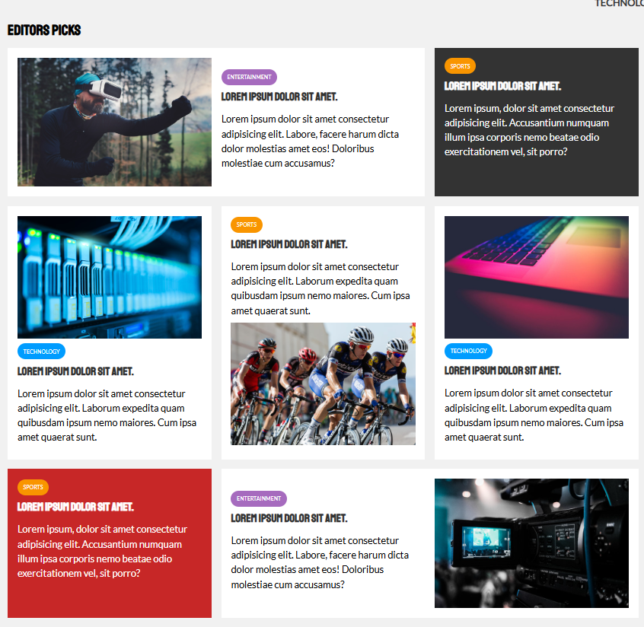

HTML (line: 102-200)

CSS(line:418-449)

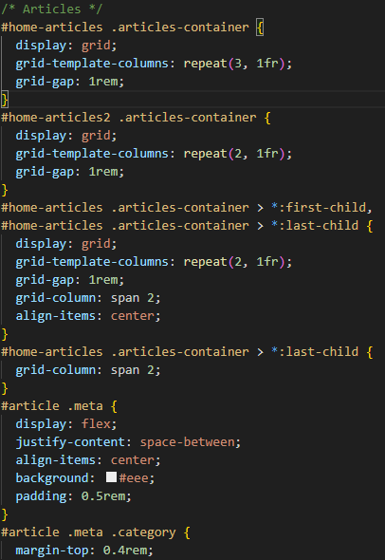

### 6 About Us, Stay Updated and Contact Us

• **Layout and Flexbox**:

* The sections (About Us, Contact Us, and Stay Updated) are organized using flexbox within the .contact-us-container.
* The layout is responsive, adjusting automatically by stacking the sections vertically on smaller screens.

• **Individual Sections**:

* **About Us**: Includes a title and description with modern styling for readability.
* **Contact Form**: Contains input fields for name, email, and message, along with a submit button styled in red for a modern look.
* **Newsletter**: Includes an email input field and a subscribe button styled in green for clear interaction.

• **Footer**: Positioned at the bottom of the page with copyright information and a project disclaimer.

• **Responsive Design**:

* The sections will adapt on smaller screens, aligning them vertically for a clean and organized look. Each section has padding and shadows for a polished, modern design.
* A screen shot of a video

  Description automatically generatedA screenshot of a website

  Description automatically generated

### 7 - Categories (Latest in Technology, Health, Science, Business and Entertainment)

### How It Works:

1. **Navbar:**
   * A black navigation bar with links spaced evenly using Flexbox.
2. **Hero Section:**
   * A blue gradient background with centered heading and text to introduce the page.
3. **News Cards:**
   * Three cards displayed side by side using Flexbox with a small gap.
   * Each card includes an image, title, description, and a "Read More" button with hover effects.
4. **Footer:**
   * A simple black footer with centered copyright text.

## Responsive Design:

* The cards will wrap to the next row if the screen is too narrow (default Flexbox behavior).

## Output:

* **Header Navigation**
* **Hero Section** with a blue background and centered text.
* **News Cards** with images, titles, and "Read More" buttons.

## 8- Author Page

### How It Works:

1. **Navbar:**
   * A black navigation bar with links spaced evenly using Flexbox. Categories include "Technology," "Science," "Culture," "Entertainment," "Sport," and "Economy."
2. **Profile Section:**
   * Displayed in the center, featuring the author's profile picture (Rick Perez) and a brief bio.
   * Accompanied by small icons for Instagram profiles.
3. **Latest Posts:**
   * Listed under the "Latest Posts" section, featuring various articles.
   * Each article includes a title, a short description, and the author's profile picture.
4. **Footer:**
   * Includes sections like "Email Newsletters," "Site Links," and "Join Our Club."
   * Features social media icons and legal information, such as copyright details and terms of use.

## 9-Subscription Page

### How It Works:

1. **Navbar:**
   * A black navigation bar with links spaced evenly using Flexbox.
2. **Subscription Form:**
   * Includes fields for email address and payment details.
   * **Mail Address for Subscription:**
     + Email: example@example.com
   * **Payment:**
     + Pay With: Card
     + Card Number: 1234 5678 9101 1121
     + Expiration Date: MM/YY
     + CVV: 123
     + Option to save card details (checkbox).
   * **Order Summary:**
     + Live News Subscription: $4.80 (Monthly)
     + Subtotal: $4.80
     + Total: $5.04 (Including $0.24 in taxes)
   * **Button:**
     + Pay USD$5.04
3. **Subscription Confirmation Page:**
   * A message confirming the successful subscription.
   * **Message:**
     + Thank You For Your Purchase
     + Order #123GR231567Y Confirmed
     + Receipt Sent to your mail address
4. **Footer:**
   * Includes sections like "Site Links," "Join Our Club," and "Email Newsletters."
   * **Site Links:** Help & Support, Privacy Policy, About Us, Contact
   * **Join Our Club:** Instagram
   * **Email Newsletters:** Subscribe button
   * **Copyright Information:** Including details and credits to creators

